Order Products Screen
Developer Gap Brief — Prime Plus Wholesale mockup (v9) vs. current build

Purpose
This brief compares the approved product-screen mockup against the current build's Order Products screen, and lists the specific gaps the developer needs to close. Reference screenshots for both are below, followed by a feature-by-feature comparison table.

1. Reference Screenshots
Target: Prime Plus Wholesale mockup v9 (landscape tablet)
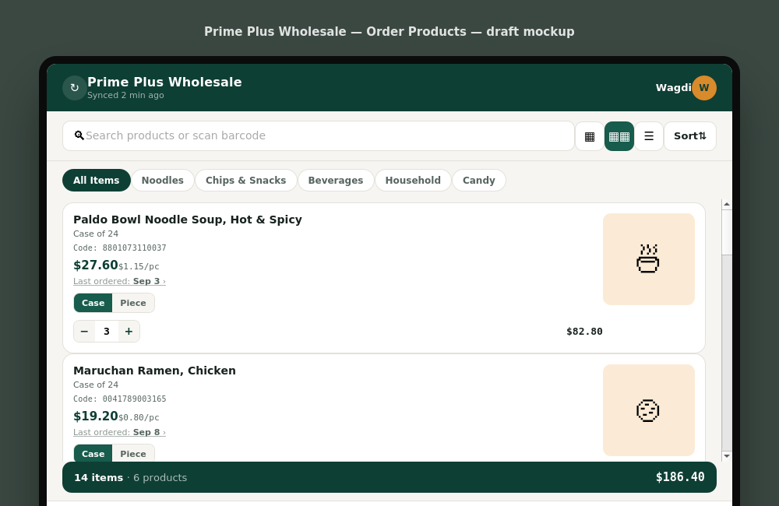
Fig. 1 — Approved mockup: category chips, case/piece toggle, clickable order history, item/product count in cart bar.
Current: live build (mobile)
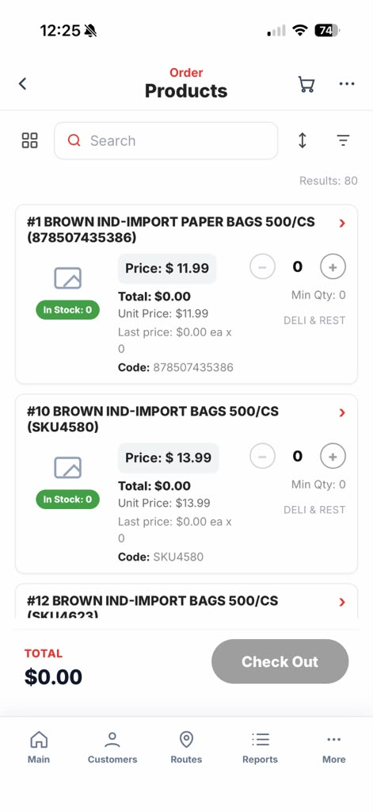
Fig. 2 — Current build: static unit price, “In Stock” badge, no category chips, total-only cart bar.

2. Gap Analysis
Each row below maps a feature in the mockup to its current state in the build, with a suggested priority for the next sprint.
Feature | Mockup (target) | Current build | Priority
Category filter chips | Horizontal chip row (All Items, Noodles, Chips & Snacks, etc.) for quick category browsing | Not present — only a filter icon in the toolbar | Medium
Case / Piece unit toggle | Per-item toggle switches pricing and ordering between Case and Piece, live | Only a static “Unit Price” label — no way to order by piece | High
Order history popup | “Last ordered” is tappable and opens a popup of past order dates/quantities | “Last price: $0.00 ea x 0” is static text, not interactive | Medium
Out-of-stock treatment | Card dimmed (55% opacity), “OUT OF STOCK” badge, +/- stepper disabled | Green “In Stock: 0” badge — reads as available; confirm stepper is actually disabled at 0 stock | High
Cart summary detail | Bottom bar shows both line-item count and unique product count (“14 items · 6 products”) plus total | Only shows dollar total | Low
Rep / business identity bar | Top bar shows business name, sync status, and sales rep avatar/name | Not visible in this screen — confirm whether it lives elsewhere in the app | Low

3. Priority Notes
- High — Case/Piece toggle and out-of-stock stepper handling are functional gaps that affect ordering accuracy; recommend addressing first.
- Medium — Category chips and order-history popup improve usability but don't block core ordering flow.
- Low — Cart summary detail and identity bar are polish items; confirm identity bar isn't already present elsewhere in the app before treating as a gap.

